Project Title: Predictive Analytics for Crop-Yield Forecasting Using Environmental and Agricultural Data
Program Title: Higher Diploma in Data Analytics for Business
Cohort Details: Higher Diploma in Data Analytics September 2026 PT – Semester 1

Git Hub link: JonCro1978/SBA25036---JC-_-strat-thinking-Capstone
Abstract:

Introduction:
In my capstone, I want to examine how crop-yield prediction can help farmers make more targeted decisions about where, when, and what they sow. This data will provide greater predictability for farmers. The issue we are trying to address is farmers investing time, money, and effort in sowing seeds in the wrong base conditions, at the wrong time, or in soil with substandard conditions, which can lead to lower yields and reduced profit. I intend to analyse historical data and use a forecasting model to help predict future yields.
According to Black in Farmers Guardian - More than eight in ten farmers (86%) say policy uncertainty is negatively affecting their farm, while three in four (74%) report increasingly unpredictable weather is making it harder to manage their farm effectively. (Black, 2026)

The Problem:
The problem is that farmers invest significant time, money, and resources in preparing land for planting. This includes acquiring and preparing the fields, purchasing seeds, planting crops, and maintaining them throughout the growing season. These activities create costs for the farmer, both financially and in time. Crop yield is also uncertain because environmental conditions such as temperature, rainfall, soil conditions, and other agricultural factors can significantly affect the result.
In my project, I intend to look at crop yield and investigate whether historical environmental and agricultural data can predict crop yield. The aim is to identify patterns in the data and determine which crops in which region is most successful; this will point to which crops are most successful for the farmers in that region. Characteristics or environmental factors have the strongest correlation with crop yield. By identifying these relationships, the project could help provide farmers with better information when making planting and crop-management decisions. This could reduce uncertainty and potentially improve the efficiency and profitability of agricultural production.
According to Food, drink and technology - McCain found that 87% of farmers say rising input costs have significantly affected profitability over the past year. More than a quarter (27%) reported either making a loss or breaking even, while a further 29% made a profit of just 1–5%. (Food & Drink Technology, 2026)

Project aim:

My aim here is to develop a predictive analytics solution that will use historical agricultural and environmental data to identify factors affecting crop yield and predict future crop yields.

My objectives:
- Identify a suitable Agricultural dataset which will contain more than 20,000 observations, ensuring that it is relevant to the research question and there are sufficient variables for analysis.
- Cleaned, prepared and evaluated the selected dataset, addressing any null values, inconsistencies, duplicates, data types, and dealing with any outliers that skew the data; this is all to ensure that the data is suitable.
- Investigation to select and ensure that an appropriate model is based on the structure of the dataset.
- Train, test and evaluate the chosen machine learning model using the appropriate performance, statistical measures and validation techniques.
- Develop clear and meaningful visualisations based on the model findings, enabling key stakeholders to interpret results, which will support these stakeholders' ability to take informed decisions.

Business Hypothesis:
Environmental and agricultural variables can be used to predict crop yield with sufficient accuracy to provide useful decision-support information for agricultural planning.
Scope:
This project will focus on developing a predictive analytics solution for crop yield estimation, drawing from historical open-access and environmental data. The in-scope work will include:
- Selecting and integrating publicly available datasets from sources such as FAOSTAT and the World Bank.
- Cleaning and exploring the data to identify relationships between yield and key variables such as temperature, rainfall and pesticide usage.
- Developing and evaluating a supervised prediction model to predict crop yield at a country or regional level for a limited set of major crops
- Implementation of a dashboard to illustrate the historical trends and model predictions

Out of scope for this project will be the following:

- Collection of data from new sources
- Collection of data from sensors
- Advanced deep learning model on satellite or drone imagery
- Integration with farm -management system systems
- Economic optimisation of planting decisions and detailed policy modelling are also beyond the scope of this work, although the predictive outputs could inform such analyses in future.

Methodology
The dataset that I intend to use will have more than 20K observations of agricultural data based on the seeds sown, the harvest yield, the weather conditions, and the soil quality, to name a few of the labels. The initial step that I will take will be to run a data description and shape codes; this will tell me what the data frame will look like, including rows, columns, and data types. I will also need to know if there are any null values and remove or replace these, as these can skew the data. Likely, I will replace the null values with the median value.
In addition, I will also need to remove any spaces in the attribute labels, as these can cause errors or failures when code is being executed. As crop yield is a continuous numerical outcome, the project will initially investigate supervised regression models. Candidate models may include linear regression as a baseline, random forest regression, and gradient boosting. If sufficient time-based data is available, forecasting methods will also be considered to predict future yields from historical observations. I will then provide a dashboard to visualise my data and the data points from the forecasts. Research on crop-yield prediction commonly uses variables such as temperature, rainfall, soil type, vegetation indices, and remote-sensing data. Frequently used evaluation metrics include RMSE, MAE, and R².
Model Architecture:
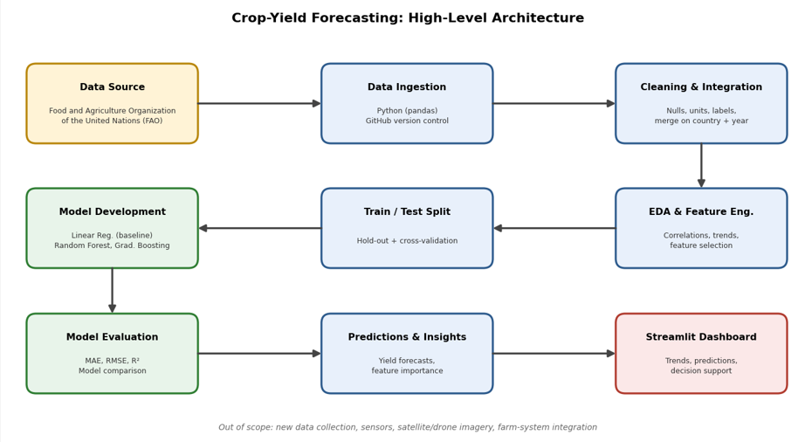
The above diagram outlines my architecture journey.
Part one, initial row, blue and yellow cubes:
- Data Source: The data is sourced from the FAOSTAT website.
- Data Investigation: In this step that data will be brough into the working environment, into the notebook where it will be worked on by the pandas, steamlit, seaborn libraries. This dataset will also be uploaded the GitHub.
- Cleaning and integration: This is the data cleaning phase, and my choices are to replace the null values with the median value and in addition removing any spaces which can be problematic to the data analysis and can potentially create errors.
Part two: blue and green cubes:
- EDA (Exploratory Data Analysis) & Feature Engineering: In this stage the model will analysis the data correlations and historical trends to selectively filter the variables that will hold the highest predicative values for the model.
- Train / Test Split: This is one of the most critical stages of the data preparation phase, prior to the machine learning commencing it will use a percentage of the data for training the model and then another subset to the testing of the model.
Part three: core Machine learning: green Cubes:
- Model development: This is the step that maps directly to the to our models. I am calling out the specific models that I will deploy, Linear regression, Random Forest and Gradient boosting.
- Model Evaluation: The quality control element is cited in this cube; we are scored at this cube in the architecture journey. It will use the exact statistical evaluation outlined in my methodology: MAE, RMSE and R2 to facilitate a direct and objective model comparison.
Part Four: Delivery & Out-of-Scope Elements (Blue, Red, & Footer)
- Predictions & Insights (Blue): Once the best-performing model is determined, it generates the final yield forecasts and calculates feature importance scores (ranking which variables, like rainfall or soil, impacted the yield the most).
- Streamlit Dashboard (Red): The final production stage of the project. It consumes generated forecasts and data insights to serve an interactive web application that displays visual trends, future predictions, and administrative decision-support metrics.
- Out of Scope Note (Footer text): Located at the very bottom, it establishes clear boundaries for the project. It explicitly excludes active real-time data-ingestion methods such as new data collection, physical field sensors, satellite/drone remote-sensing imagery, and direct farm-system software integrations.

Data Source:
The data source I intend to use will be obtained from publicly available agricultural and environmental sources, including FAOSTAT and the World Bank Open Data. The agricultural data will provide crop, country, year, harvest area, product, and yield measures. Environmental data will provide variables such as annual rainfall and temperature. The datasets will be integrated using common geographic and time fields, subject to compatible coverage and units. The final source selection will be confirmed after assessing data completeness, licensing, and suitability for modelling.
Expected deliverables:
The expected deliverables will include a documented and cleaned agricultural dataset, exploratory data analysis of crop-yield patterns, a comparison of supervised regression models, and an evaluation of model performance using MAE, RMSE, and R². A Streamlit dashboard will be developed to present historical yield trends, relationships between environmental variables and yield, model predictions, and feature importance. The final deliverables will also include technical documentation, an explanation of limitations, recommendations for future development, and the completed capstone report.

Ethical and Legal Considerations
The project will use publicly available, aggregated data rather than personal information collected from individual farmers. The licensing conditions of FAOSTAT, World Bank and any other selected sources will be reviewed and acknowledged. Data will be used only for the stated academic purpose, and the original providers will be cited appropriately.
The model will be presented as a decision-support prototype rather than a replacement for professional agricultural advice. Limitations relating to data quality, missing values, geographical coverage, changing climate conditions and model uncertainty will be clearly explained. Care will also be taken not to present predictions as guaranteed outcomes, because inaccurate predictions could lead to inappropriate planting or resource decisions. Code and datasets will be stored securely, and any confidential or personally identifiable information will be excluded from the project.

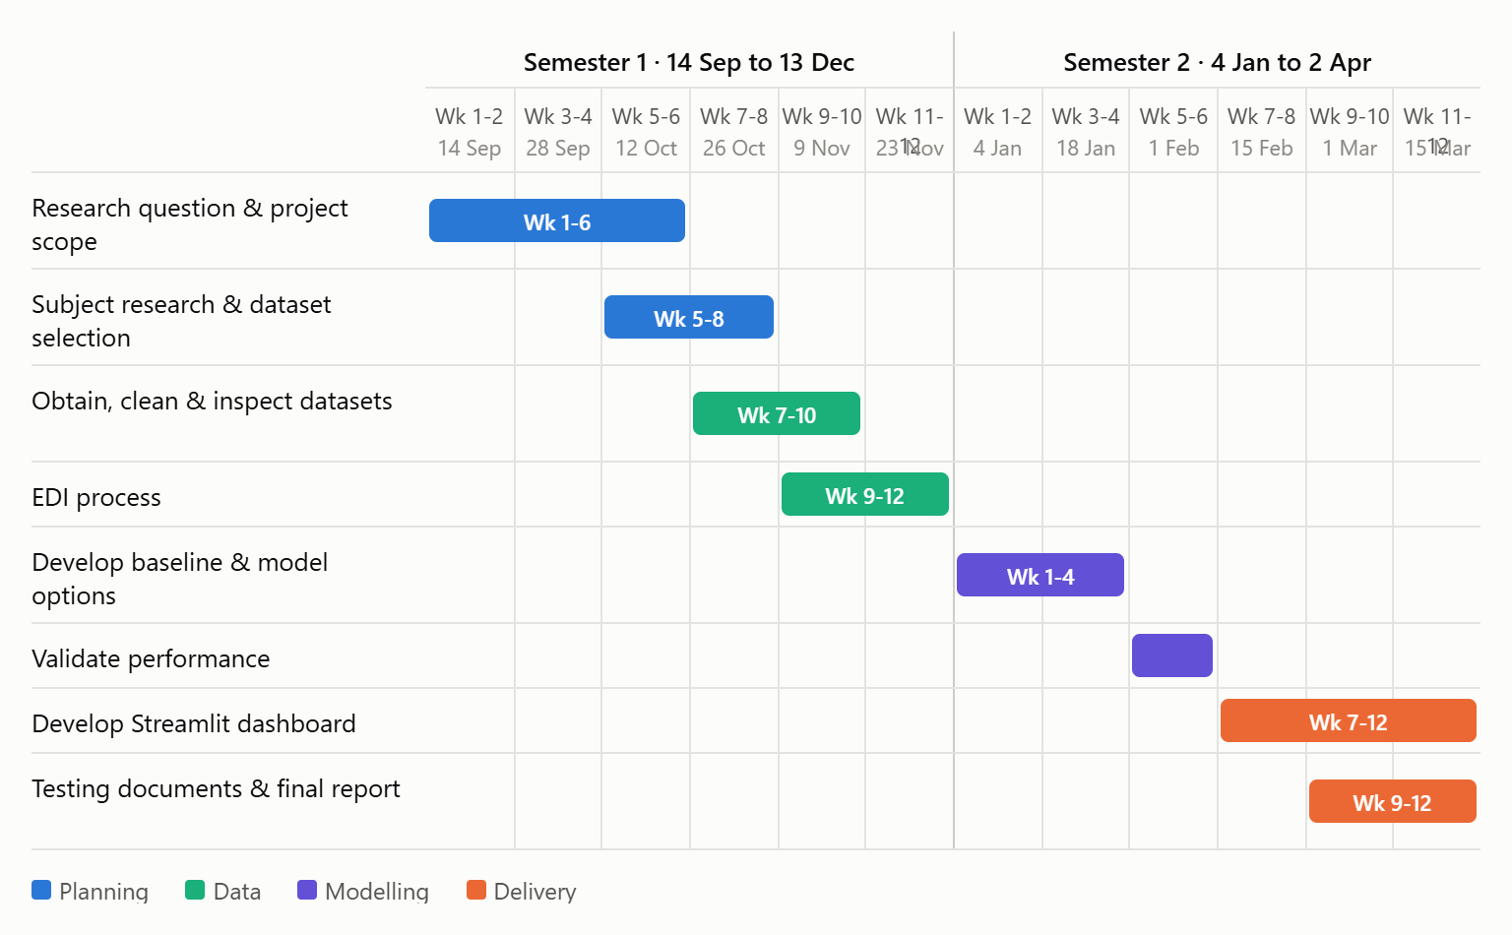

Data set was acquired from the following website: Home | Food and Agriculture Organization of the United Nations

Citation
Dixita Rajpopat et al. (2025) Predictive Analysis for Crop Yield, International Journal of Science, Engineering and Technology. Zenodo. Available at: https://doi.org/10.5281/zenodo.17293428.
Package1_Agriculture_CaseStudy3.pdf

Crop Models: Important Tools in Decision Support System to Manage Wheat Production under Vulnerable Environments – DOAJ

Crop Models: Important Tools in Decision Support System to Manage Wheat Production under Vulnerable Environments
and Technology, F., Drink (2026) Analysis: Farmers warn food security is becoming harder to protect, Food and Drink Technology. Available at: https://www.foodanddrinktechnology.com/news/70601/analysis-farmers-warn-food-security-is-becoming-harder-to-protect/ (Accessed: 10 October 2026).
Black, A. (2026) Uncertainty means farmers cannot plan, says new survey, Farm News | Farmers Guardian. Available at: https://www.farmersguardian.com/news/4536896/uncertainty-means-farmers-plan-survey?utm_workspace=Farmers+Guardian (Accessed: 10 October 2026).

AI declaration:

This is the chat to create the gantt chart:
https://claude.ai/share/22c5854a-1f92-49d2-a7ca-6142876075b2

